

PELAGOS CETACEAN RESEARCH INSTITUTE

Terpsichoris 21., 16671 Vouliagmeni
Tel.-Fax: +30-210-8960108
e-mail: pelagos.info@otenet.gr
website: www.pelagosinstitute.gr

CETACEAN OBSERVATION REPORT

OBSERVER’S PERSONAL DATA
Full name:
Telephone number:
Mobile number:

GENERAL INFORMATION
Date of observation: | Local time of observation:
Location:
Exact Place:
(e.g “Sand beach North-east side of Naousa bay” or “1km north of Chios port”)

CASE OF DEAD CETACEAN
SPECIES AND MEASUREMENTS
Small Cetacean  (0,7 – 3,5 m) | Large Cetacean  (3,5 – 22 m) | Species, if known (e.g Striped dolphin):
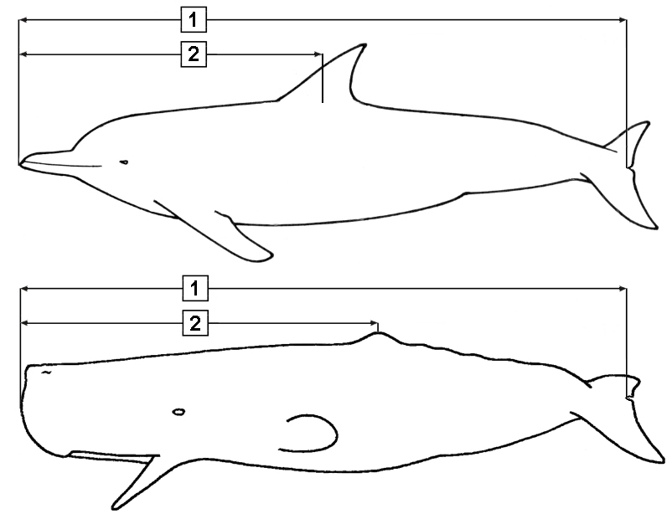
1) Total length (tip of beak to notch at the middle of flukes): m
2) Length until the middle of dorsal fin: m

- The measurements must be done with a stretched tape measure, in parallel with the animal and not following the body curves.

- The measurements must be taken with the exact centimeters, e.g. 1,86 m

Whole Cetacean Cut tail or head

Number of teeth on the half upper jaw (right or left): |  |  | (including the empty spaces, if  there are teeth missing)
Number of teeth on the half lower jaw (right or left): |  |  | (including the empty spaces, if  there are teeth missing)

PHOTOGRAPHS
It is important and necessary in every case (even if the animal is in an advanced stage of decomposition) to take the following pictures:

- The head with an open mouth so as the teeth to be obvious (number of pictures)
- The entire animal from both sides (number of pictures)
- genital area, which is behind the abdominal area (number of pictures)
You can send the pictures at Pelagos Cetacean Research Institute by e-mail or by post (see top)

PELAGOS CETACEAN RESEARCH INSTITUTE

Terpsichoris 21., 16671 Vouliagmeni
Tel.-Fax: +30-210-8960108
e-mail: pelagos.info@otenet.gr
website: www.pelagosinstitute.gr

2nd page
LIVE CETACEANS
WITHOUT ANY OBVIOUS PROBLEM
(the cetacean swims normally, even if it is near the coast)
1) If it is possible, try to photograph the cetacean and send the pictures together with this form.

2) You don’t have to do anything in this case. If the animal is very close to the coast, it will be good if you can monitor for sometime its behaviour.

3) For the good of the animal as well as of the people, the animal must not be approached or disturbed by the crowd

INJURED OR SICK
(the animal cannot swim normally, or is stranded on the shore)
1) Very important: Do not even approach the blow hole, on the top of their head from where the animal breathes. Wear a mask and do not touch the animal if you do not wear gloves. There is a danger of transmitting to the animal human viruses – fatal for cetaceans - and if the animal survives, it might transfer them to the entire population.

2) Take photos of the cetacean and send the pictures together with this form to Pelagos Cetacean Research Institute by e-mail or by post (see top).

3) The stress caused by the crowd can kill cetaceans. Try to keep the crowd away and let only the absolutely necessary people to stay.

4) Always approach the animal very carefully. The cetaceans can make abrupt movements and accidentally cause injuries.

FIRST AIDS

- Never try to return the animal in the deep and never try to tie up and drag it. It’s like if you tied up a man’s arms and legs and drag him into the sea. A lot of cetaceans have been drowned this way, but also people have been killed by cetacean’s violent reactions. Keep the animal in shallow waters and stabilize it so that it is seated with the belly on soft sand or put something soft to avoid injuries from rocks. The blow hole on the top of their head must be out of the water and the animal must always be with its dorsal part up.

- Do not move it without a reason. Never roll it. Never drag it from the front flips and never use hooks, nets, timbers etc. Also never squeeze the skin because it can be injured very easily. Make a draft stretcher from soft and resistant fiber.

- Cover the body with a wet, light-colored and soft cloth, keeping always all the fins, the blow hole and eyes free. If the area is very sunny you must create some shadow for the animal.

GENERAL NOTES (for live or dead cetaceans)
Note anything else you think is important or necessary (e.g For dead cetaceans: obvious injuries, entanglement in fishing gear, marks on the body or the head etc. For live cetaceans: description, strange movements or behavior).

